Simple Linear Regression on Salary
Cailey Crandall
2026-04-26

Introduction
This analysis examines the relationship between employment (in years) and salary using a simple linear regression model.

Correlation Coefficient
r <- cor(df$Employment..in.years., df$Salary)
r
## [1] 0.8238657
Interpretation: Employment and salary have a strong positive correlation (r = 0.824). This means that as years of employement increase, salary tends to increase. A value this close to 1 incidicates a strong linear relationship between the two variables.

Scatter Plot
plot(df$Employment..in.years., df$Salary,
main = "Employment (Years) vs Salary",
xlab = "Employment (in years)",
ylab = "Salary ($)",
pch = 16,
col = "steelblue")
abline(lm(Salary ~ Employment..in.years., data = df), col = "red", lwd = 2)
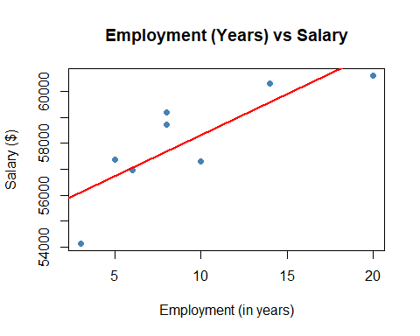
Interpretation: The scatter plot shows a positive linear relationship between employement in years and salary. As employement increases, salary tends to increase. The data points follow a roughly linear trend, and the red regression line confirms this.

Simple Linear Regression Model
model <- lm(Salary ~ Employment..in.years., data = df)
summary(model)
##
## Call:
## lm(formula = Salary ~ Employment..in.years., data = df)
##
## Residuals:
## Min 1Q Median 3Q Max
## -1968.3 -904.0 287.3 806.1 1512.8
##
## Coefficients:
## Estimate Std. Error t value Pr(>|t|)
## (Intercept) 55152.98 940.50 58.642 1.65e-09 ***
## Employment..in.years. 316.77 88.97 3.561 0.0119 *
## ---
## Signif. codes: 0 '***' 0.001 '**' 0.01 '*' 0.05 '.' 0.1 ' ' 1
##
## Residual standard error: 1288 on 6 degrees of freedom
## Multiple R-squared: 0.6788, Adjusted R-squared: 0.6252
## F-statistic: 12.68 on 1 and 6 DF, p-value: 0.01192

Significance of the Independent Variable
Interpretation: The p value for employement in years is 0.0119, which is less than the significance level of 0.05. Therefore, employement in years is a statistically significant predictor of salary. We reject the null hypothesis that there is no correlation between the variables.

Significance of the Model
Interpretation: The F statistic p-value is 0.0119, which indicates that the model is statistically significant.

R² and Adjusted R²
Interpretation: The $R^{2}$value of 0.6788 indicates that approximately 67.9% of the variation in salary is explained by employment in years. The adjusted R^2 of 0.6252 accounts for the number of predicors in the model and is a more conservative estimate. Both values suggest a moderately strong model fit.

Root Mean Square Error (RMSE)
rmse <- sqrt(mean(model$residuals^2))
rmse
## [1] 1115.208
Interpretation: The RMSE of approximately 1,288 represents the average difference between the observed salary values and the values predicted by the model. This means the model’s predictions are off by about $1,288 on average, which is relatively small compared to the salary range in the dataset.

Conclusion
This analysis found a strong positive linear relationship between employment in years and salary (r = 0.824). The simple linear regression model was statistically significant (p = 0.0119), with employment in years explaining approximately 67.9% of the variation in salary (R² = 0.6788). The regression equation is Salary = 55,152.98 + 316.77 × Employment, meaning salary increases by approximately 316.77 for each additional year of employment. With an RMSE of $1,288, the model demonstrates reasonable predictive accuracy.

